Section 5: Basic SQL

Write a query to list the names of all employees along with their department names. Include the employee's ID, full name, and department name.
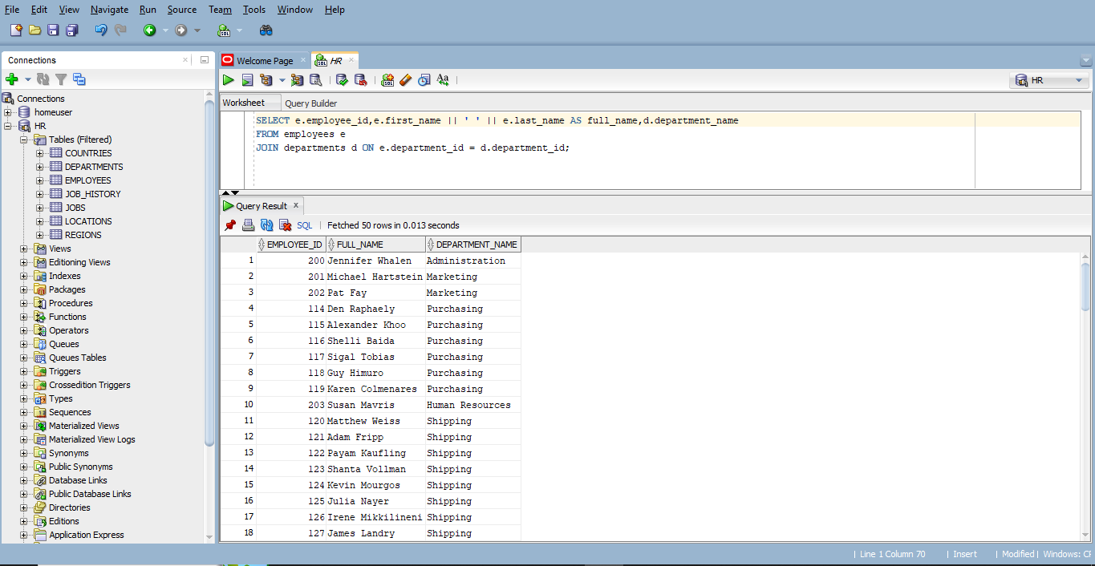
Write a query to count the number of employees in each department. Include the department name and the number of employees.
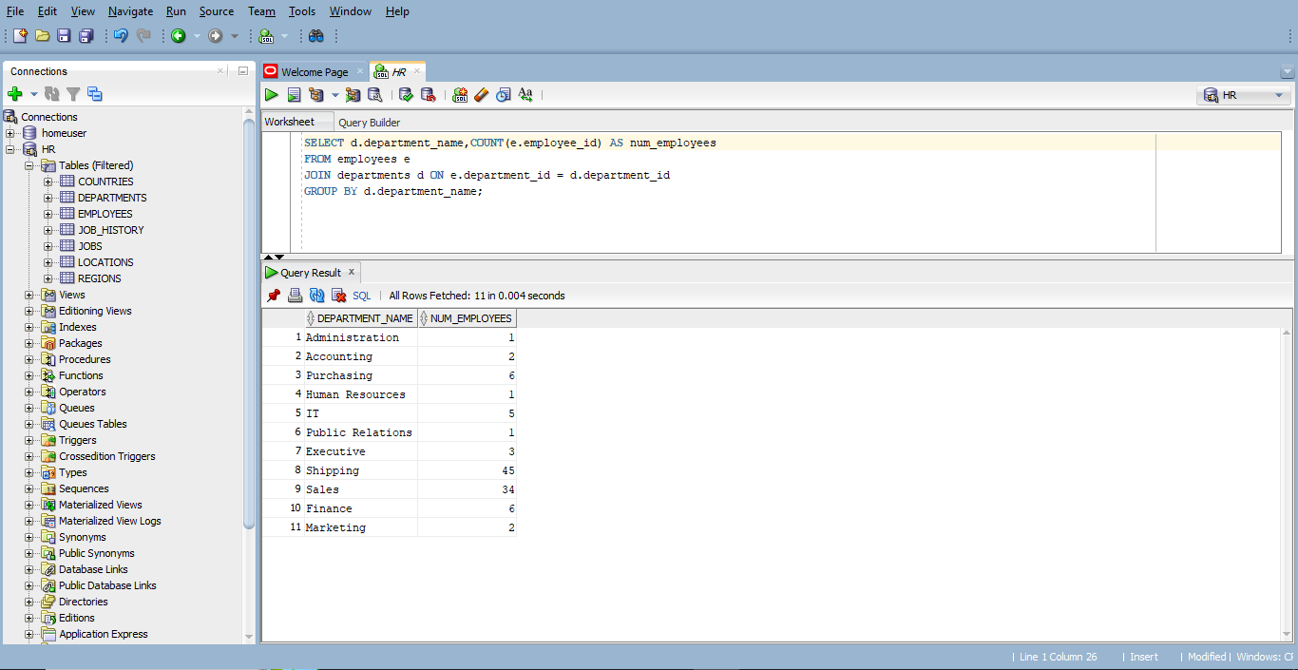
Write a query to list all job titles available in the company.
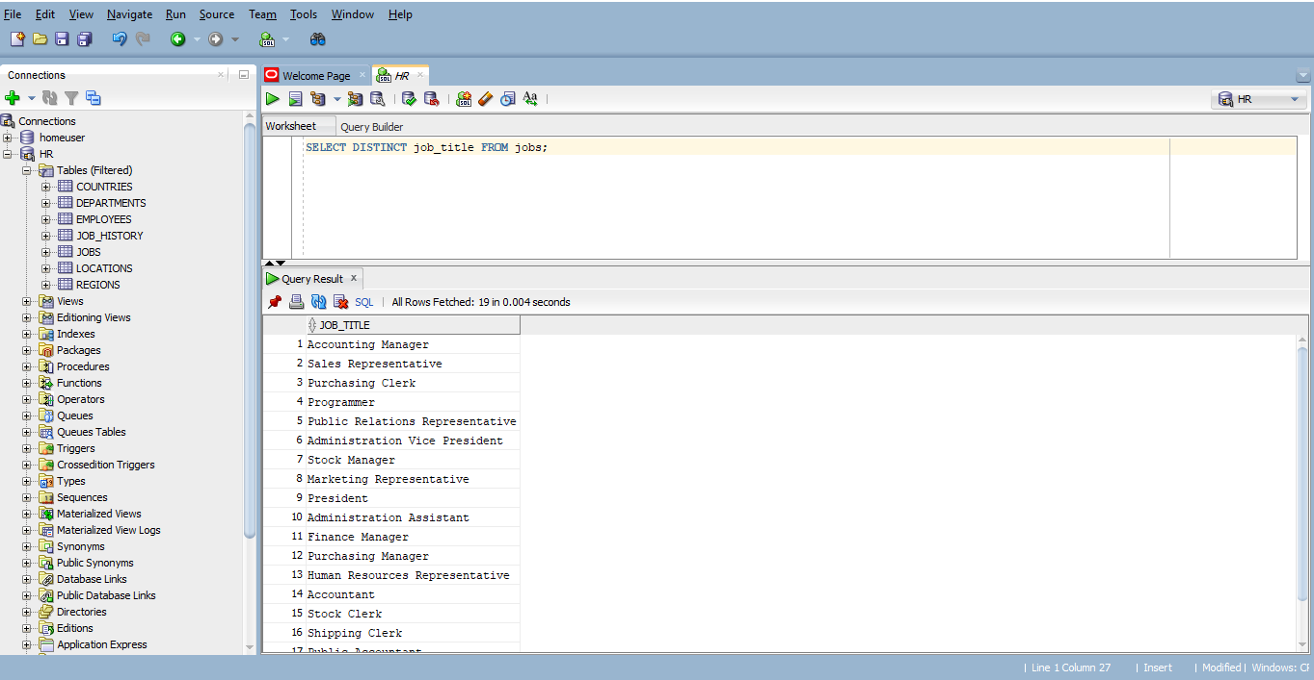
Write a query to find all employees who earn more than $5000 per month. Include the employee's ID, full name, and salary.
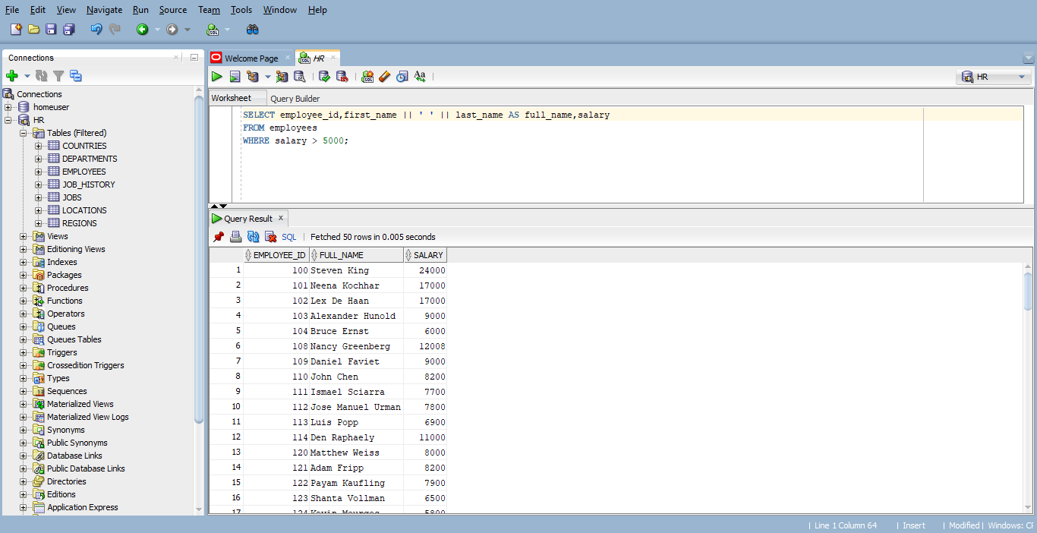
Write a query to list the names of all departments along with their location.
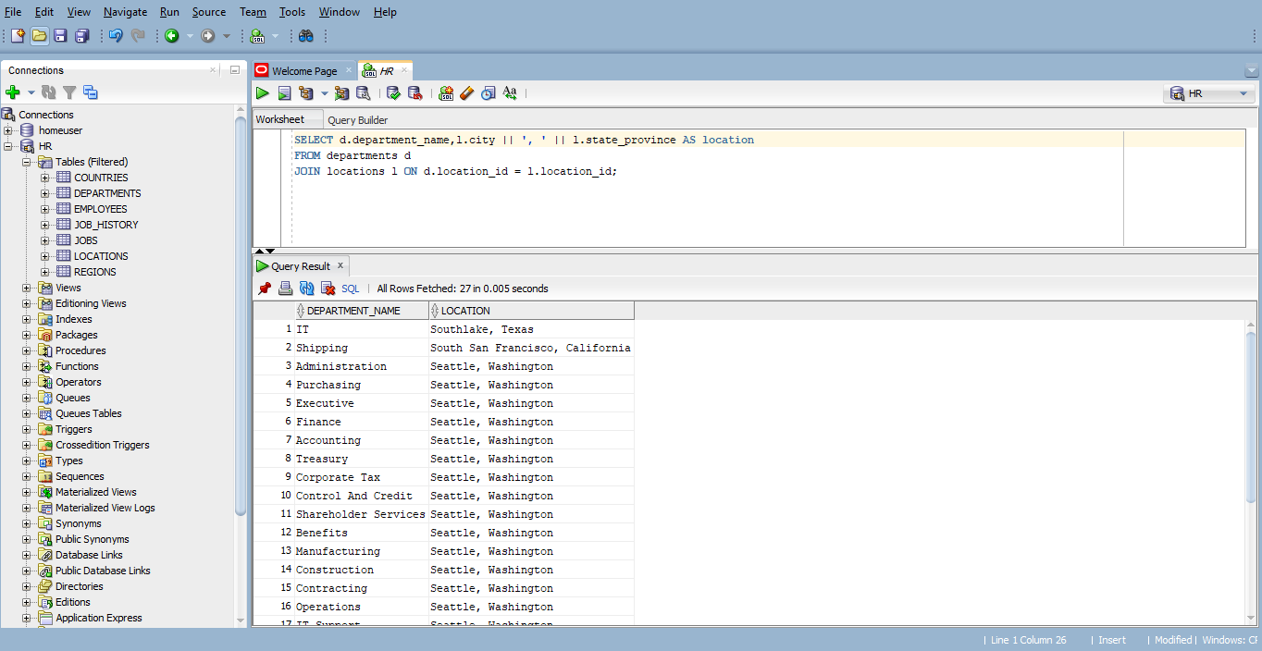
Write a query to find the earliest hire date in the company. Just show the date.
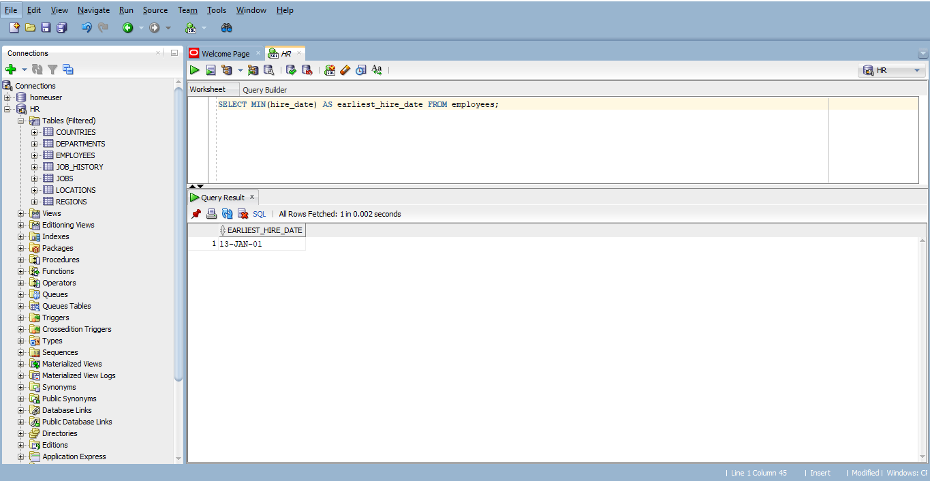
Write a query to list all employees who were hired after January 1, 2010. Include the employee's ID, full name, and hire date.
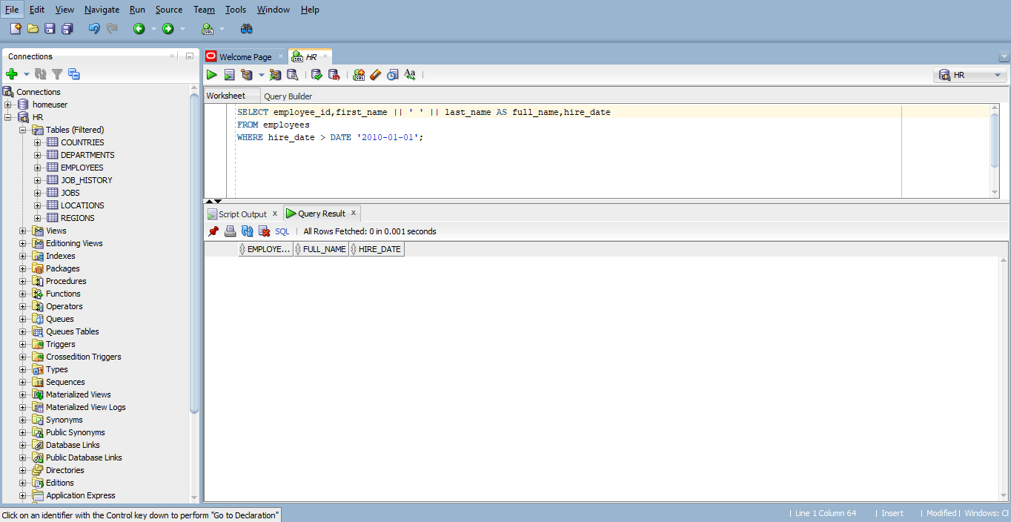
Write a query to calculate the average salary of all employees in the company.
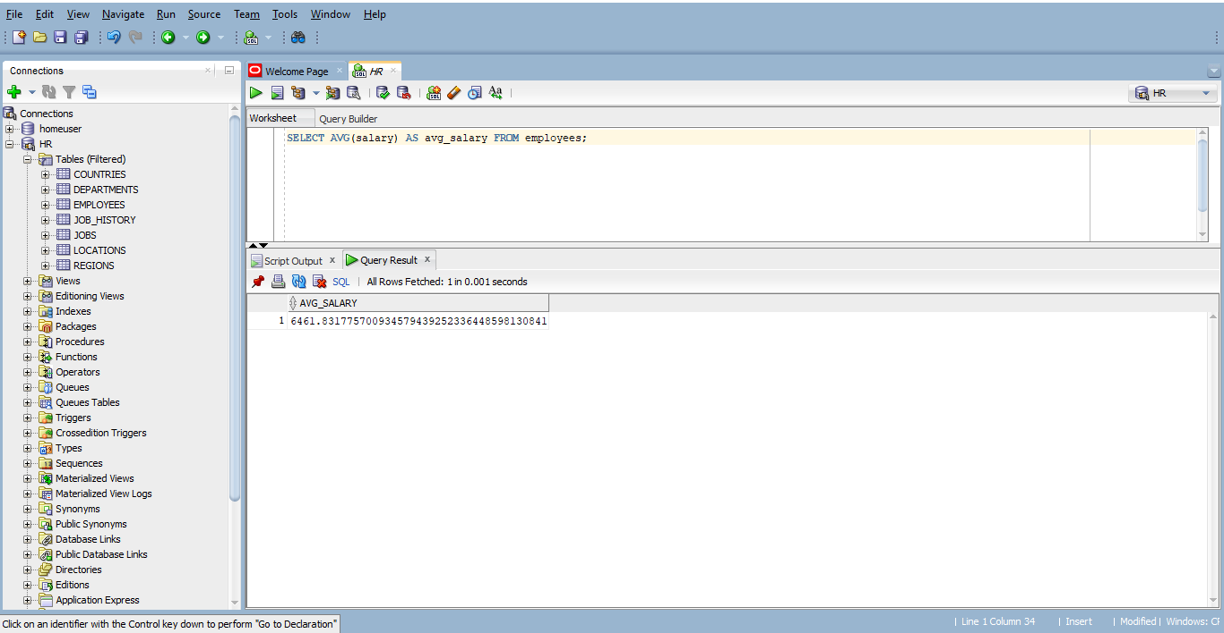
Write a query to list all department names.
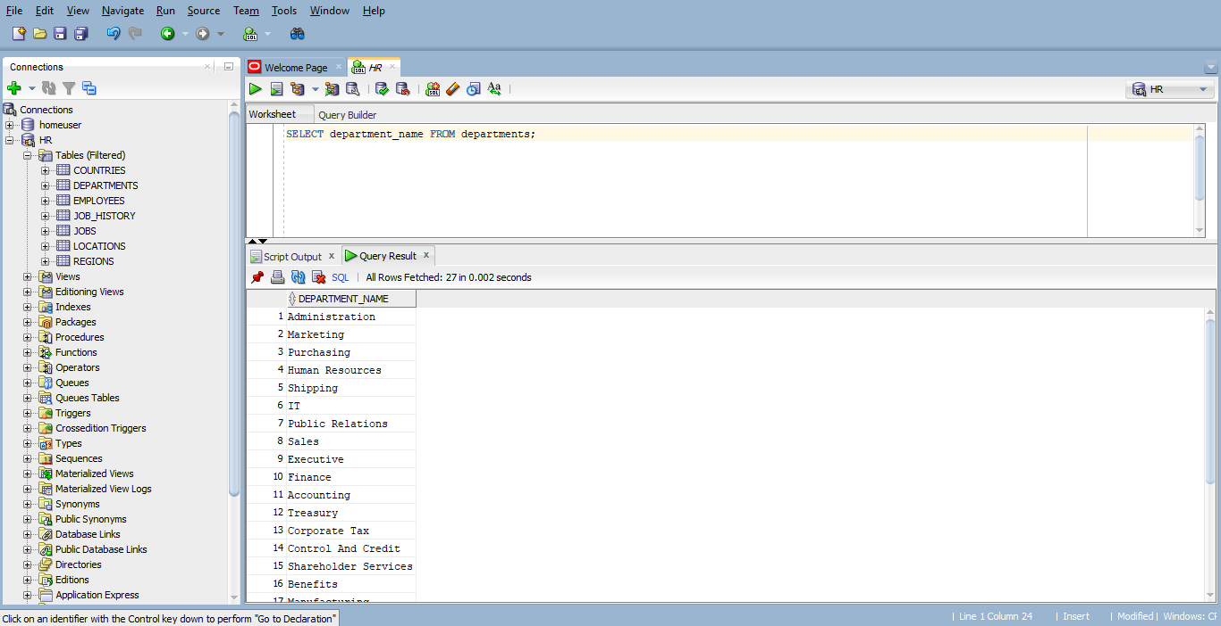
Write a query to find all employees with the job title 'Sales Representative'. Include the employee's ID, full name, and job title.
